Quiz

Match the definitions (10)
- Density
- Malleable
- Lustre
- Conductor
- State of Matter
- Toxicity
- Conduct heat
- Melting point
- Boiling point
- Color

____ The temperature at which a solid turns into liquid.
____ A general form that could describe whether the substance is in its solid liquid or gas phase
____ A term that refers to a substance that easily allows electricity to flow through it
____ The temperature at which a liquid turns into a gas
____ Defined as mass/volume and refers to degree of compactness of a substance
____ A term that refers to the ability of a substance to be hammered into sheets
____ The degree at which a substance is poisonous
____ Refers to when a substance has shine
____ Refers to the ability of a substance to transfer heat throughout the substance
____ Could be red, yellow, purple, green, blue, purple etc.

Give an example of 2 objects and the primary compound in the object. Explain what property the compound has that is the reason it is used in that object.
Example: Aluminum is used in bicycles because it is light.
1.

2.

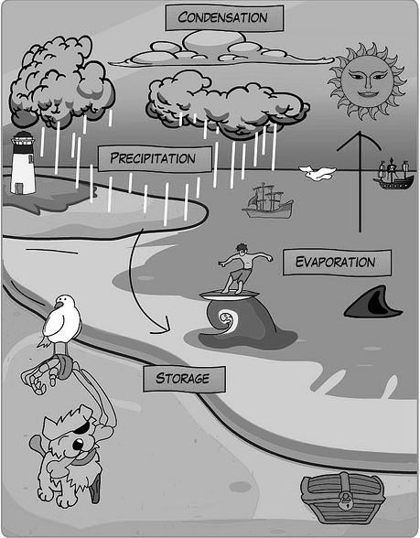
Kevin Jarrett

Is it chemical or physical change (6)
- Leaves turning color in the Fall
- Cutting a piece of paper in two
- Aspects of the water cycle (see diagram for help)
- Adding vinegar to baking soda causes bubbles to form and a gas to be released
- Yeast acts on sugar to form carbon dioxide and ethanol
- Digesting food
Name 4 indicators of chemical change

- ___________________________________________
- ___________________________________________
- ___________________________________________
- ___________________________________________
