DNA Discovery Timeline
_____ Friedrch Miescher used white blood cells he was able to isolate something he called “nuclein” because he recognized it came from the nuclei of the cell
_____ Fred Griffen did an experiment with 2 different strains of a bacteria known as Pheumococcus. He found that one strain was infectious to mice and the other was not infectious. He also noticed that the infectious strain could transfer a “principal” to the R strain offspring to create future infectious offspring
www.frikipix.com

_____ Oswald Avery, Collin Macleod and Maclyn McCarly were inspired by Fred Griffen, but instead of using mice they did experiments in test tube and proved that is was DNA that carried the genetic information. They were also the first to isolate Nucleic acids.
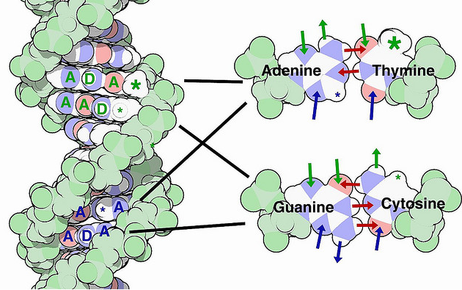
dullhunk
_____ Erwin Chargaff isolated DNA and measured the
amounts of the 4 nitrogenous bases. He found
that the amount of adenine=amount thymine and
amount guanine=cytosine.

_____ Phoebus Levene found that DNA was by linking a phosphate group to a deoxyribose sugar. These where in turn linked to one of 4 nitrogenous bases. He believed that there were the same amount of adenine, thymine, guanine and cytosine. He called his theory, the Tetra Nucleotide Theory.
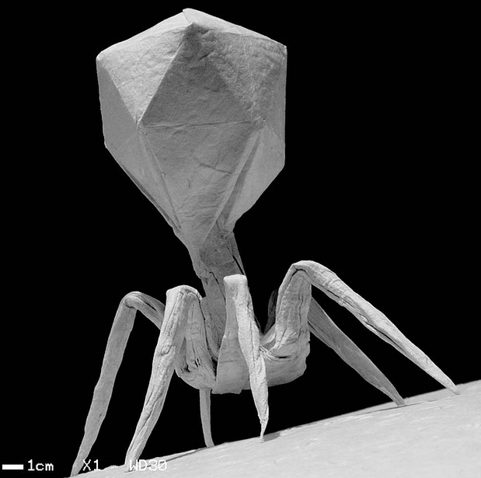
origamiwolf

_____ Alfred Hershey and Martha Chase- worked with bacteriophage
to prove that it was DNA alone that was necessary for carrying
the information to produced new bacteriophage.

_____ Linus Pauling discovered the corkscrew shape of DNA using x-ray crystallography. He called it an alpha helix shape. He also proposed that DNA was a triple helix.
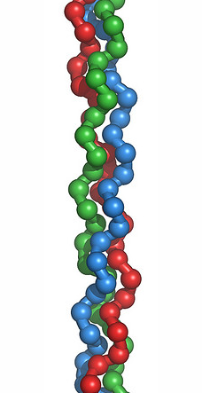
Ethan Hein

_____ James Watson and Francis Crick published the first
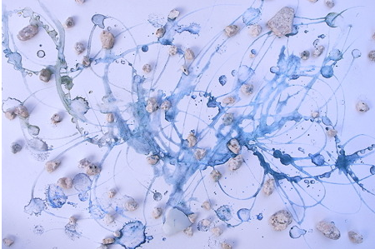
kawase ai
accurate model of DNA as a double helix. They used
information the gathered form Phoebus Levene,
Oswald Avery, Erwin Chargaff, Linus Pauling, and
Rosalind Franklin to come up with their model.

_____ Rosalind Franklin and Maurice Wilkins made x-ray diffraction patterns of DNA indicating the simplicity and density of DNA. This helped prove Watson and Cricks theory.
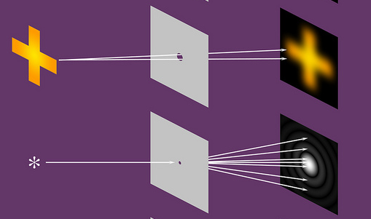
Dominic Alves
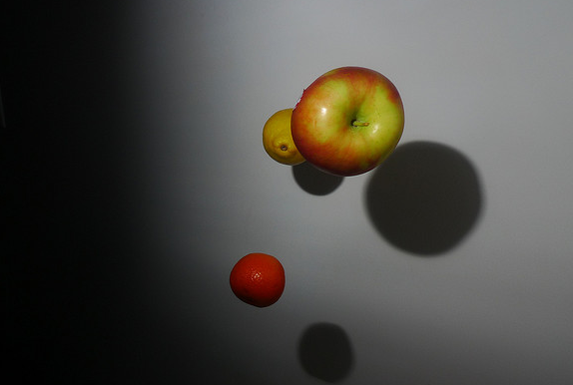
Kevin Glaser
_____ Thomas Hunt Morgan worked with fruit flies to
determine that chromosomes definitely functions
in heredity. He found that genes are carried on
chromosomes in specific places

_____ Walter Sutton and Theodor Boveri both worked independently and proposed the idea that genetic material is carried on chromosomes. He also proposed the idea that an egg and a sperm only carry one chromosome from each pair, therefore allowing random inheritance from each parent.
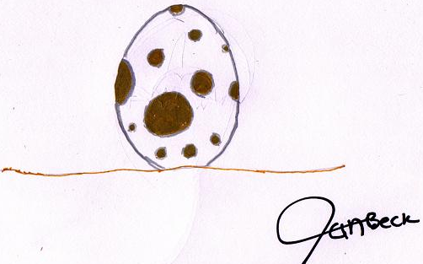
Ian Beck

