DNA Extraction Lab
Purpose:
The purpose of this lab is to extract DNA from a banana and see DNA molecules (this procedure actually took scientists many years to discover).

Remember:
- Cell membranes are layers of lipids, or fat molecules
- That DNA is found in the nucleus of a cell,
- That enzymes speed up chemical reactions.

Brief summary of procedure
- The cells will be chemically treated to break open the cell and nuclear membranes.
- The part of the cell mixture containing DNA will be separated from the cell membranes and associated proteins (gloppy portion),
- Then solution containing the dissolved DNA will be altered so that the DNA can no longer remain dissolved. It will be “precipitated,” and observable with the naked eye.

Supplies:
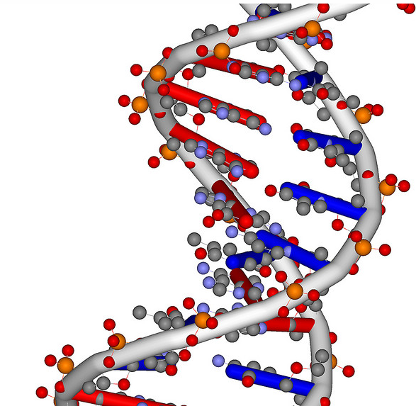
Geoff Hutchison

- Banana
- Salt
- Clear liquid dish soap
- Warm water
- Beakers
- Coffee filter
- Ethanol
- Ziploc bag

Procedure
- Collect a Ziploc bag and quarter of banana.
- Peel banana mash it in the Ziploc bag
- Collect a small beaker with 40 ml of water
- Add 1 teaspoon of salt to it and stir till it is dissolved.
- Add the salt water to the Ziploc bag
- Create a straining station. To do this:
- Collect a coffee filter, and a medium beaker.
- Place the coffee filter over the beaker in such a way that a well is formed for the solid contents to sit in strains.
- Now pour the contents of the Ziploc bag through the coffee filter
- Once completely strained remove the coffee filter and discard left over contents. This will take several minutes so be patient. You may choose to look at the questions while you wait.
- Collect a stir rod and dish soap.
- Add about 1 teaspoons of dish soap to your solution and stir gently trying not to create bubbles.
- Collect about 15 ml of ethanol in a granulated cylinder
- Add the ethanol slowly to the beaker so that the ethanol layer creates a layer on top of the watery layer. You may want to tip the beaker slightly as you add the ethanol, allowing the ethanol to slowly run down the side of the beaker.
- Wait 3-minutes to allow DNA to appear
- Slowly stir with your stir rod to examine your banana’s DNA

Congratulations-You just extracted DNA!!!

Macfixer

Questions
Damien Navas
Damien Navas
1. It is important that you understand the steps in the extraction procedure
and why each step was necessary. Each step in the procedure aided in
isolating the DNA from other cellular materials. Match the procedure with
its function:

PROCEDURE FUNCTION
A. Filter banana mush through ___ To precipitate DNA
the filter from solution
B. Mix banana with ___ Separate components of
salty/soapy solution the cell
C. Mashing the banana ___ Break open the cells
D. Addition of ethanol to filtered ___ Break up proteins and
extract dissolve cell membranes

2. What did the DNA look like? Relate what you know about the chemical
structure of DNA to what you observed today.

3. Explain what happened in the final step when you added ethanol to your
banana extract. (Hint: DNA is soluble in water, but not in ethanol)

4. A person cannot see a single cotton thread 100 feet away, but if you
wound thousands of threads together into a rope, it would be visible much
further away. Is this statement analogous to our DNA extraction? Explain.

5. What part of the cell did the DNA come from?

Experiment adapted from The Natural History of Genes: http://raven.umnh.utah.edu/new/teachkits/dna/introduction.html
Questions adapted form http://www.nespal.org/edout/PlantDNAExtraction.pdf

