Discovering Isotope
Website: google “isotope simulation” and pick the first one. Or phet.colorado.edu/en/simulation/isotopes-and-atomic-mas
- Then download the program and open it
- Your assignment is to use 3 different elements and fill in the following chart

Element: _______________________________
Average atomic mass:__________________________
Possible Isotopes:
Name | Number of protons | Number of neutrons | Atomic mass | Abundance (%)
1)
2)
3)
4)
Draw a pie graph: |  | Draw a visual representation of the abundance

Element: _______________________________
Average atomic mass:__________________________
Possible Isotopes:
Name | Number of protons | Number of neutrons | Atomic mass | Abundance (%)
1)
2)
3)
4)
Draw a pie graph: |  | Draw a visual representation of the abundance

Element: _______________________________
Average atomic mass:__________________________
Possible Isotopes:
Name | Number of protons | Number of neutrons | Atomic mass | Abundance (%)
1)
2)
3)
4)
Draw a pie graph: |  | Draw a visual representation of the abundance
Try naming some isotopes
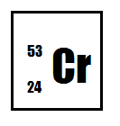
Name:
Number of protons:
Number of neutrons:
Atomic mass:
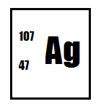
Name:
Number of protons:
Number of neutrons:
Atomic mass:
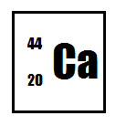
Name:
Number of protons:
Number of neutrons:
Atomic mass:
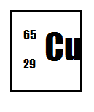
Name:
Number of protons:
Number of neutrons:
Atomic mass:
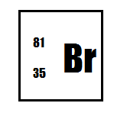
Name:
Number of protons:
Number of neutrons:
Atomic mass:

