**Billy’s**

**Bus Trip**

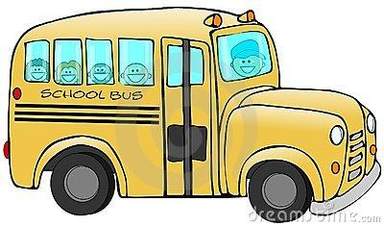

Chris the cat was driving the bus.

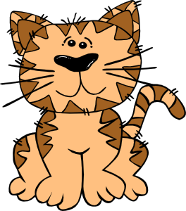

Billy the bee got on the bus. He wants to go to the playground.

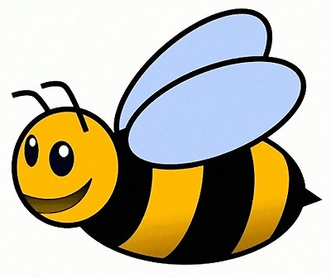

How many animals are on the bus?

There are **two** animals on the bus.

 

**Two** dogs got on the bus.

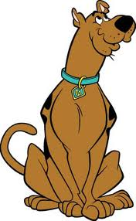 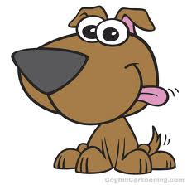

How many animals are on the bus?

There are **four** animals on the bus



**Four** bears got on the bus.

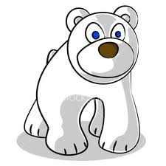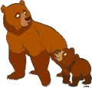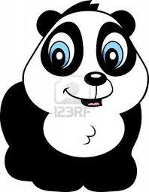

How many animals are on the bus?

**Eight** animals are on the bus.



**Two** rabbits got on the bus.

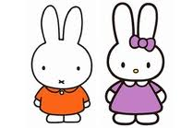

How many animals are on the bus?

There are **ten** animals on the bus.



**Five** elephants got on the bus.

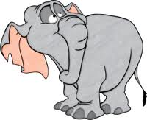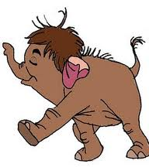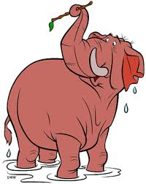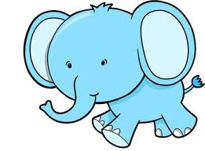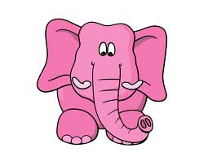

How many animals are on the bus?

There are **fifteen** animals on the bus.



**Three** monkeys got on the bus.

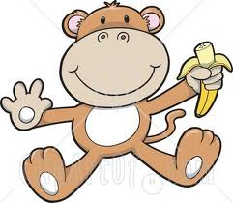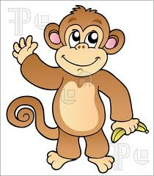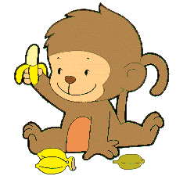

How many animals are on the bus?

**Eighteen** animals are on the bus.

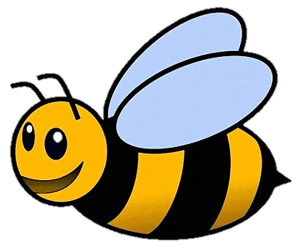

Billy got off the bus at the playground!

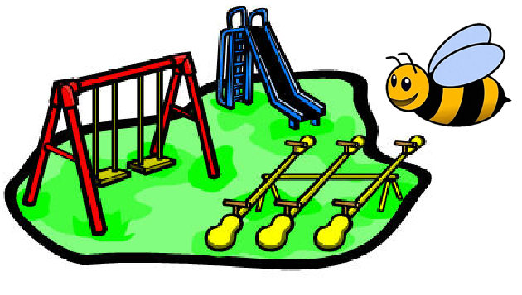

The end!

